

**Initial Software Requirements Specification**

**Web Project Title:** **ASAP**

**Type: Ecommerce Application**

**Platform:** **PHP**, **My SQL**

**Ecommerce:** Magento

**Prepared By**

# **INDRODUCTION**

## Purpose

The purpose of this document describes the functional and non-functional requirement for **ASAP** e-commerce website. This SRS document covers the functional documentation of how the website will work.

**ASAP** has a powerful admin panel in which admin or content writer can add/edit/remove Products or Services, its category etc. also admin can manage the look of web site.

## Document Conventions

Specific terminology is used throughout the specification of the system

**User Profile**: stands for the profile of the customer (person) opened in the software. One person can have multiple profiles using different emails. A profile can be linked to none or one account type.

**Person**: defines a real person who has an identity defined by class attributes. A person can have multiple profiles and consequently multiple accounts. For instance a person can have a basic and a business account.

**Account:** defines an entity that enables the user to operate throughout the system and perform purchases.

**Payment:** defines an entity that enables an account to perform a payment transaction using one of alternative methods.

**Purchase:** defines an entity that encapsulates a purchase object. A purchase is specified by a unique number and status thus using the Status class.

**Cart:** stands for a container that holds selected products during the session and is included by a purchase.

**Cart Products:** as the name itself defines an entity that makes possible operations of addition, deletion, and selection of products in and from the cart.

## Intended Audience and Reading Suggestions

The intended audience is:

* **Client**: is the customer who will buy this system.
* **Developers:** are who will translate the document into codes after understanding the requirements.Developersmust read the whole document.
* **Project Manager:** Who will supervise the implementation of the system

# OVERALL DESCRIPTION

## Product Perspective

**ASAP** is a bilingual website. The main purpose of ASAP is to provide the facility for customers to view and purchase the different products via online interfaces, and to enable users to book a time slot for a salon’s service. Customers are identified properly and are able to perform online transactions by various methods. The customers can view products and add it to his shopping cart and he must login/ register to proceed payment. If a customer register at once, he can use that user name and password for further shopping. The customer can remove item from his cart before he checkout.

There will also provide the facility for the users to view the different services and can also see the profile of staff members who are providing those services. The users can also see the location of the branch, which the staff member is working at. The map view of all branch locations will be available.

Users can search for a service or a specific staff member and book an available time slot through the system.

The website design will be responsive so it can be accessed by most of modern electronic devices with various screen sizes. The system supports both English and Arabic.

The system should enable the admins to manage the content of the website. Both service booking and e-commerce sections are to be managed by the super admin. In addition to these controls, Branch admin will be able to create staff profiles and assign them the services they can provide and create the availability calendars for each staff.

# WEBSITE INTERFACE / FEATURES

This section includes the requirements that specify all the fundamental actions of the website.

## Customer View

**Website Structure**

1. **Home page**

1.1 **Header Section**

1.1.1 Quick Contact No.

1.1.2 Sigin Link

1.1.3 Register Link

1.1.4 Company Logo

1.1.5 Language Selector

1.1.5.1. English

1.1.5.2. Arabic

1.1.6 Wishlist

1.1.7 Cart

1.1.8 Menu Section

1.1.8.1 Home

1.1.8.2 About Us

1.1.8.2.1 Staff

1.1.8.2.1 CSR

1.1.8.3 Categories

1.1.8.4 Services

1.1.8.5 Shop

1.1.8.6 Offers

1.1.8.7 Gallery

1.1.8.8 Book an Appointment

1.1.8.9 Contact Us

1.1.9 Search bar

1.2 **Main Banner** **Section**

1.2.1 Sliding Banner Image with Title

1.3 **About Us**

Brief text about ASAP Company

1.4 **Best Seller Section**

List of Best seller’s products with sliding effects

1.5 **New Arrival**

List of new products with sliding effects

1.6 **Footer Section**

1.6.1. Payment Accepted

1.6.2. Youtube Links

1.4.3. Copyright

1.4.4 Footer menu(FAQ, Privacy Policy, Return Policy, Terms & Conditions, Careers)

1. **About Us**

2.1. About Us description

1. **Staff**

3.1. Page contains profiles for staff members with their provided services and the branches they work at.

1. **Categories**

4.1 Listing all the products belongs to the selected category.

1. **Services**

5.1 List of all service categories.

1. **Shop**

6.1 List of all shop products.

1. **Offers**

7.1 Page contains current product or service offers.

1. **Gallery**

8.1 Photo gallery with list of events conducted.

1. **CSR**

9.1 Corporate social responsibility content.

1. **Book an Appointment**

9.1 This page contains service booking form.

1. **Contact Us**

10.1 Company address with Google map and feedback form.

**Home Page**

The home in the website give user immediate feedback that the website has started and is loading.

The home page for **ASAP** is shown below.

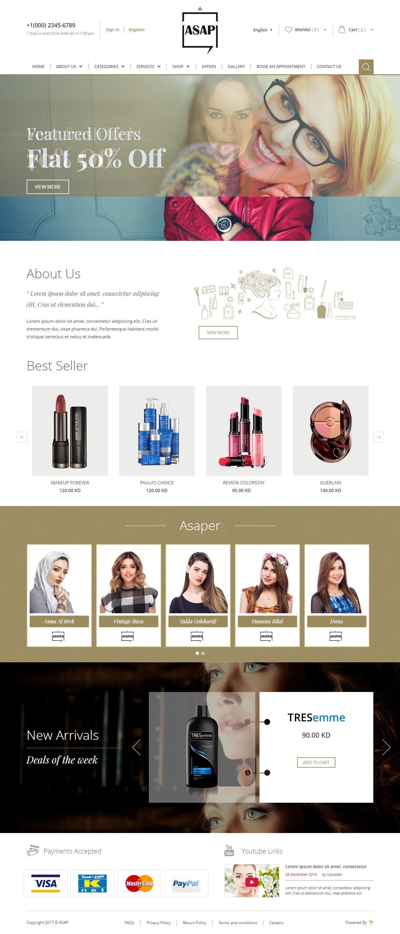

**Header Section**

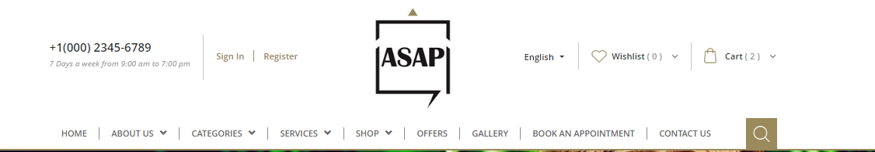

When the user browse website first he will see the home page of **ASAP**. It has a header area in which has a logo, navigation menu area, call us number, language switcher, whishlist and cart. There has an option to search, login, register for the user.

In home page header area search, Navigation Main Menu, Login, Register, Call Us info, wishlist and shopping cart are the sections. Following are the details about these icons

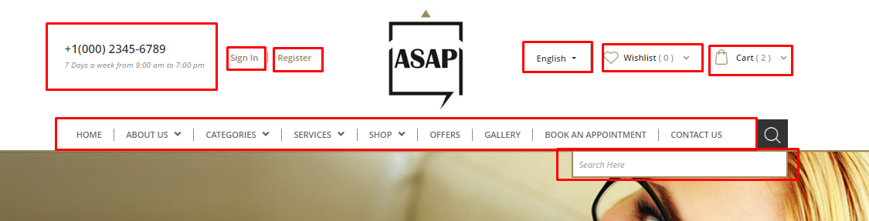

**Call Us:** This section displays contact us no of the application owner to interact with their shoppers query.

**Sign in:** User who registered with **ASAP** use this link to login. After successful login it will take the user to his account. Where he can manage his details.

**Register:** This link is used to create new account with **ASAP**. After successful submission user need to activate his account from his mail.

**Language Switcher**: This link is a drop down, user can switch the language from English to Arabic and Arabic to English.

**Wishlist:** Wishlist is the user’s bookmarked items for his future purchase. This link navigate to the wishlist page contains all the bookmarked items. This link shows the total whishlist item’s count.

**Shopping Cart:** The user who want to buy the products or service will be added to the cart. On click the cart button it will show all the products or service the client added. The cart list contains item thumbnail with name and quantity. It has an option to remove item from the cart. The bottom of the cart list will show cart total and subtotal of the items. Cart link shows the total items in the cart.

**Navigation:** This section used to navigate the whole website. These menus are added from backend admin console of the application. This will be limited to maintain the design.



**Search:** This is used to search the product or service with some keywords. The right end of the Navigation shows the search icon and on click of the icon will appear a text box to enter search keyword. On searching it will take you to search page getting results for keyword the user searched.

**Shop by Category**

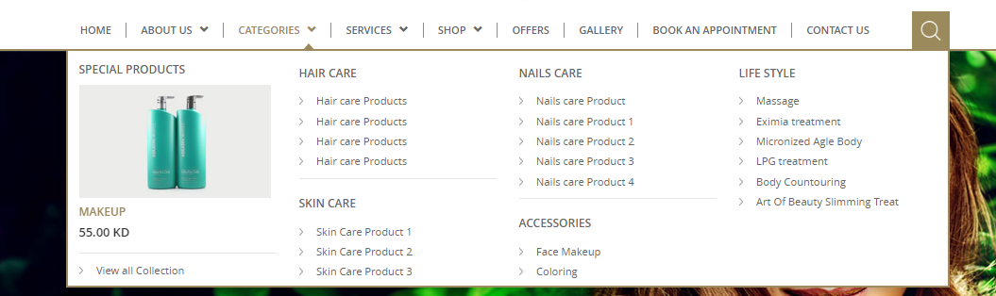

This is also navigation menu for all categorized products. Product categories are created and managed from admin console. The active categories will be listed in this menu. Each category menu can be navigate to its detailed page contains all the active products belongs to the same category. There will be auto scroll listing special products and this will be added from the admin backend.

**Shop by Service**

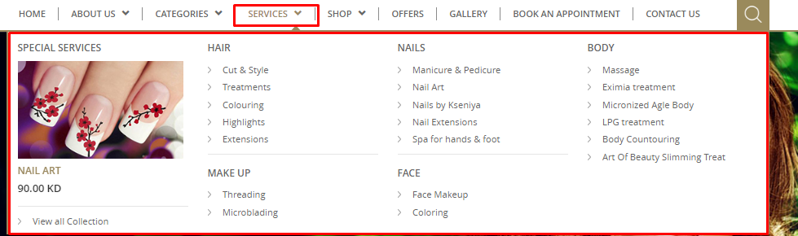

The services navigation menu contains all the service categories. Service categories are created and managed from admin console. The active categories will be listed in this menu. Each category menu can be navigate to its detailed page contains all the active services belongs to the same category. There will be auto scroll listing special services and this will be added from the admin backend.

**Shop by Shop**

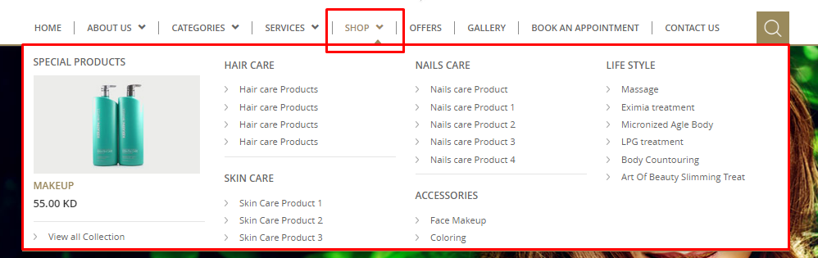

The Shop navigation menu contains all the shop categories. Shop categories are created and managed from admin console. The active categories of will be listed in this menu. Each category menu can be navigate to its detailed page contains all the active services belongs to the same category. There will be auto scroll listing special services and this will be added from the admin backend.

**Main Banner Section**

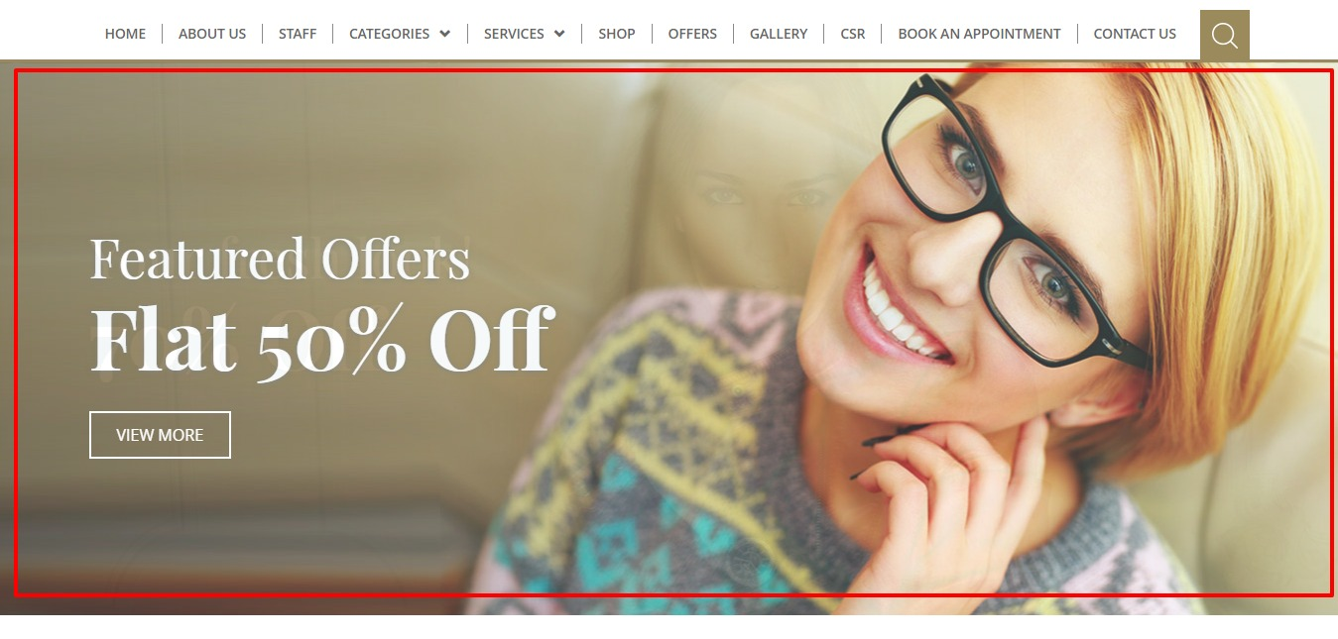

The **ASAP** comes with full-fledged banner slider in the home page. Each and every slides in the banner will be managed from admin dashboard. Banner will made ordered using number system. Banner will have the facility to have a link and a title.

**About Us Section**



This section contains the summarise content of the ASAP with a graphic sketch and the ‘View More’ button will navigate to the About Us page. This content is manage from the CMS section of the admin panel.

**Best Seller Section**

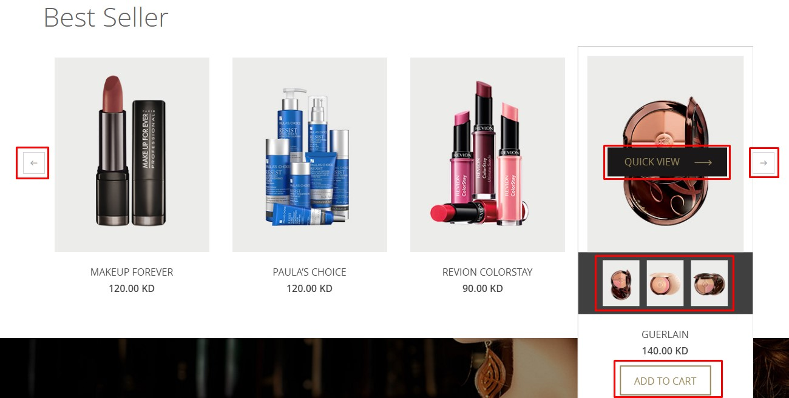

The best sellers section displays the best selling products from the application. The default products listing limit is four and if more than four there will be active pagination to next and previous.

On the mouse of the item will be get selected effects with showing ‘Quick View’ , ‘Add to Cart’ buttons and the item optional images. Quick View button will redirects to the detailed view of the item and Add to Cart button will add the item quickly to the cart.

**ASAPER**



This is a section in the home page just below of the best seller. In this section it shows, a list of ASPER with sliding effect. Each ASAPER will be listed up here by the approval of website administrator. It will redirected to each profile of the ASAPER while on click on the profile photo. The details of profile page is explained in the ASAPER profile page section.

**New Arrivals**

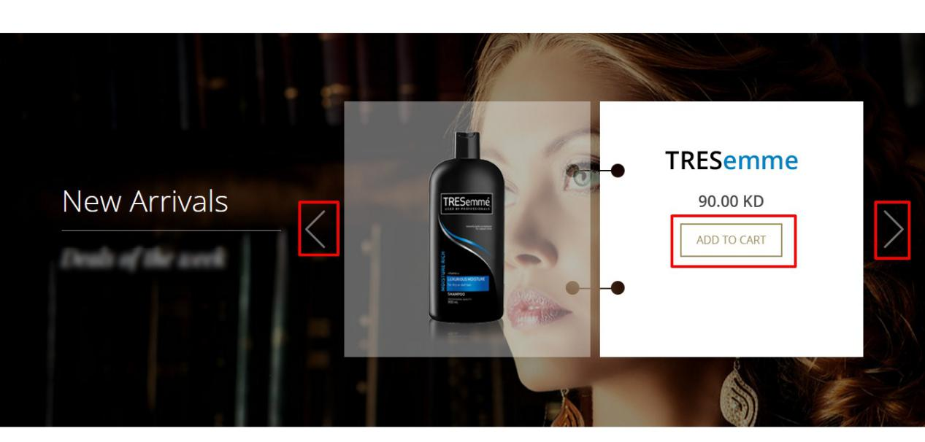

In the new arrival section latest products will listed automatically. To view next new arrivals click on next button in the section. This will be shown using carousel functionality. This will show products from different categories which are added recently. This cannot be set as admin wish. The product image is on the left and its name and price on the right side of the slider. Add to Cart button will add the item quickly to the cart.

**Footer Section**

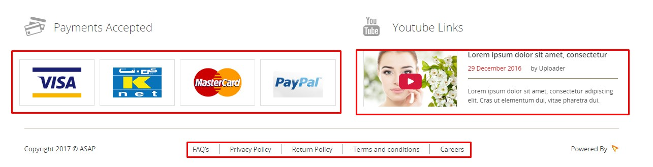

In the footer area includes Payments Accepted, Youtube Links, Copyright and footer links.

The logo of the Pagment gateway providers which are Visa,Knet,Master and Paypal is listing in the footer left block.

Youtube channel links of the ASAP will list with sliding effects and it will be hyper linked to the Youtube channel.

Copyright of ASAP with current year info will be in the bottom left block.

The footer menus FAQ, Privacy Policy, Return Policy, Terms and Conditions and Career which are the information pages created from the CMS section of admin panel.

**About Us Page**

This page will explain about ASAP company. This page will not have any side navigation. Header and footer same as the Home page. There will be a static image below the navigation menu and it can be manage from admin.

The information content will managed from the admin panel by the CMS.

The page screen shot is given below.

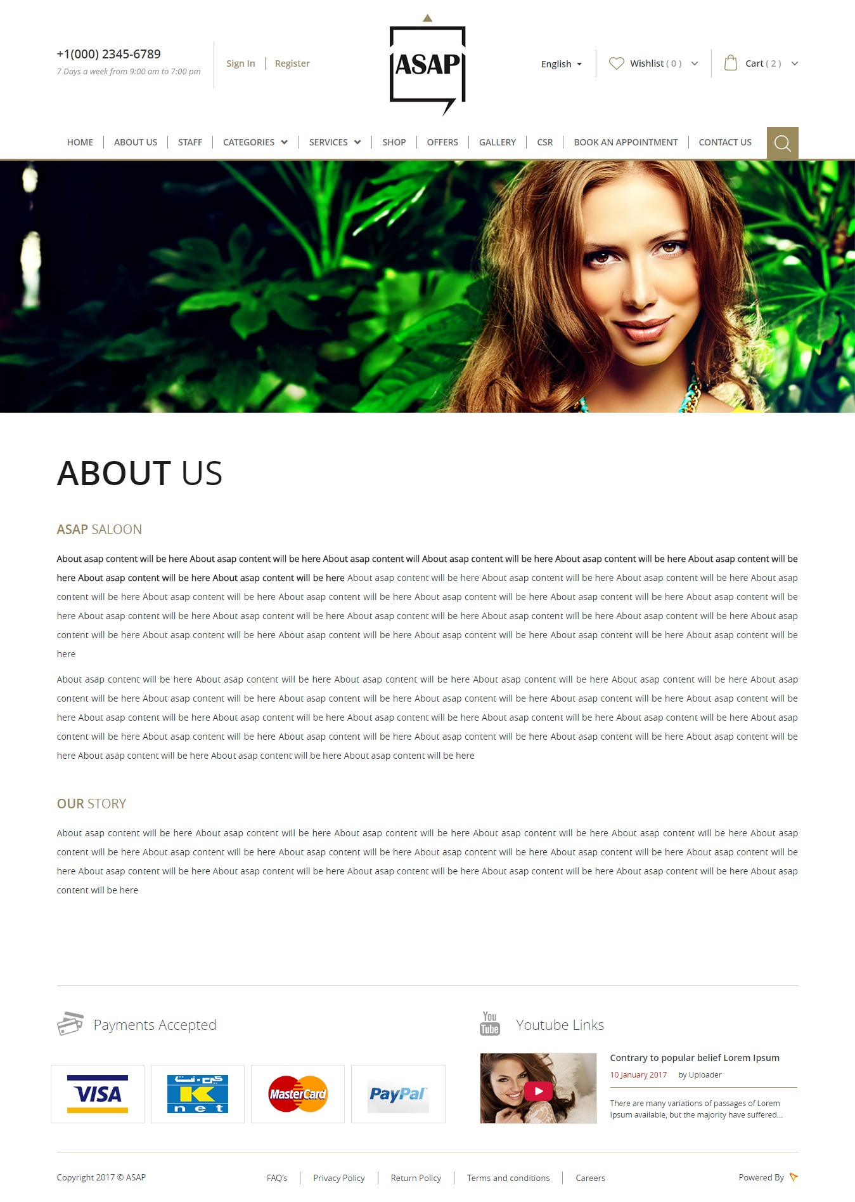

**Staff Page**

This page contains profiles for staff members with their provided services and the branches they work at.

The page screen shot given below.

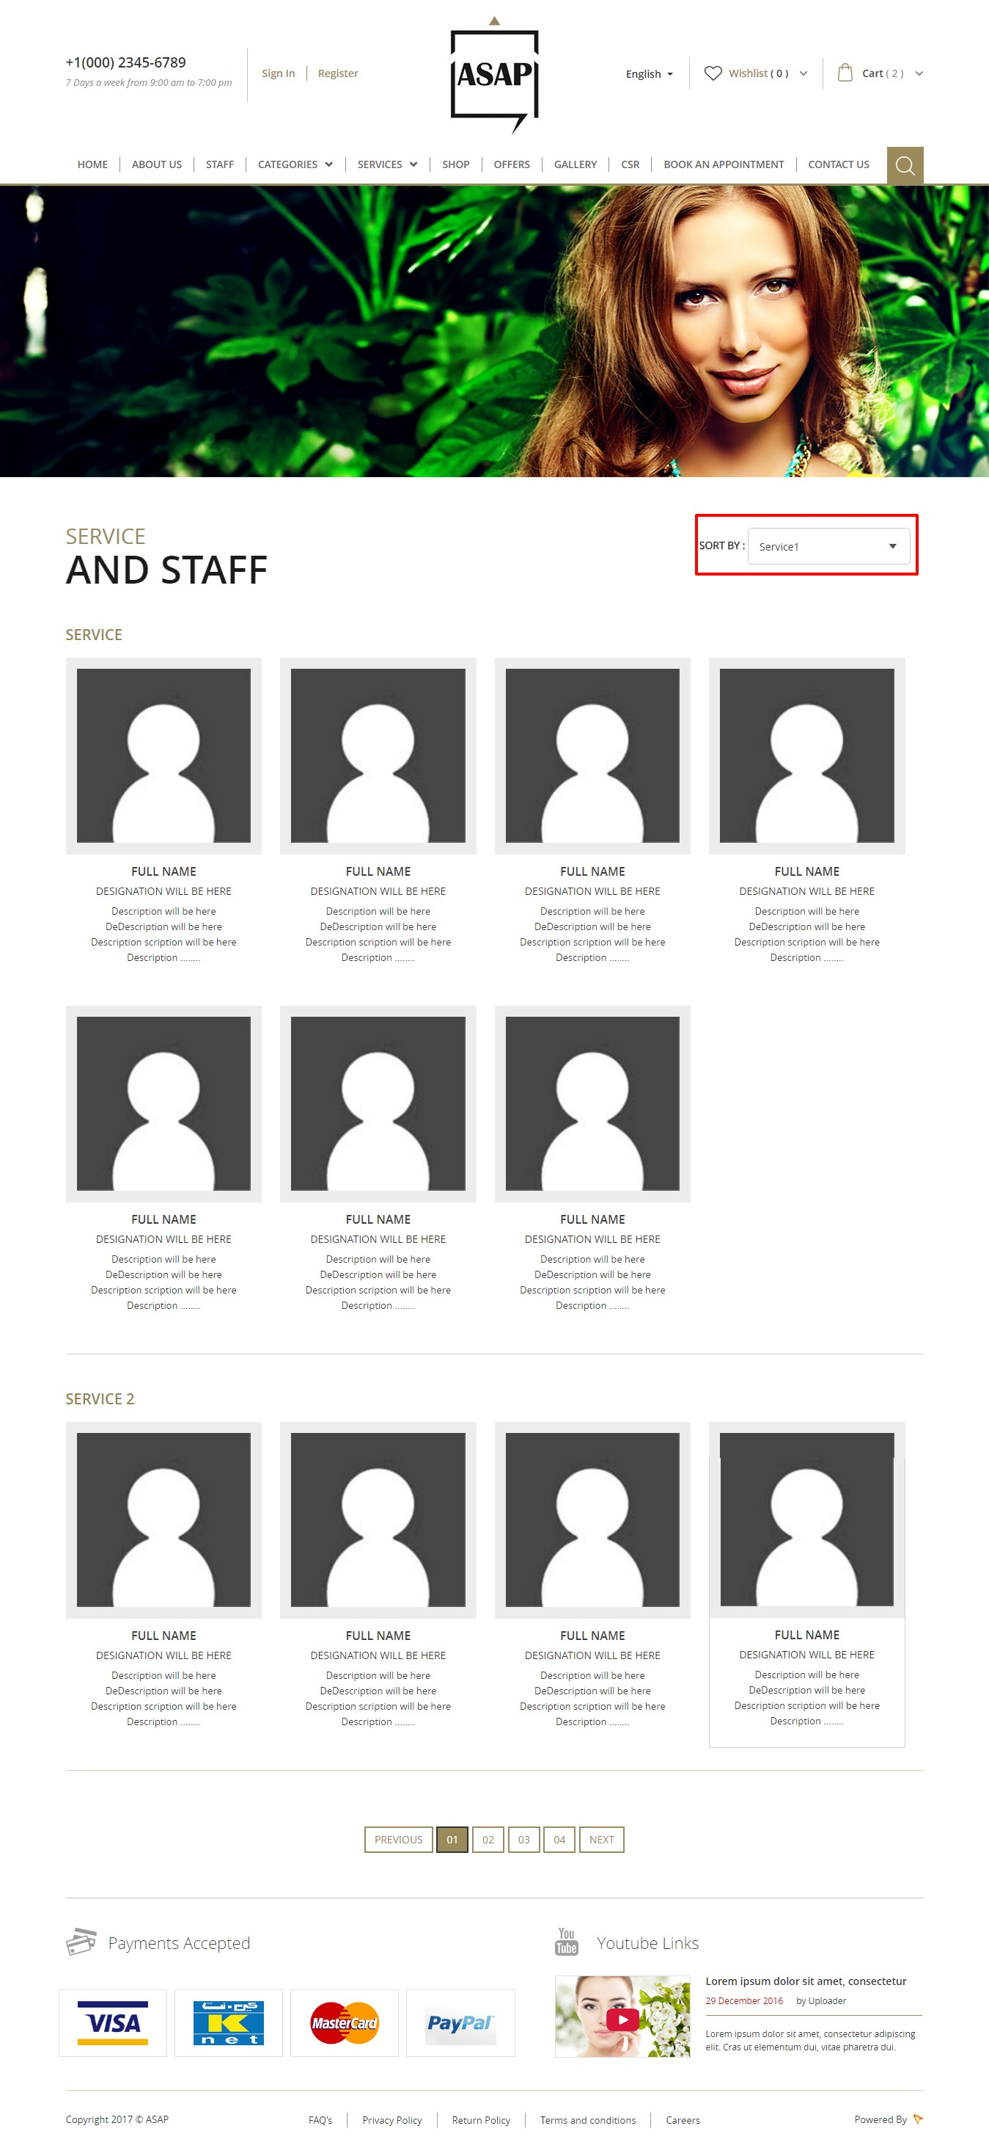

This page listing all the staff members and order by their service. The basic staff details Name, image, designation and small description are in the listing. The service name re will be the subheading. Staff list can sort by service name. The read more button will navigate to the detailed view of the Staff. Pagination will be in the bottom of the page.

Admin will be able to create staff profiles and assign them the services they can provide and create the availability calendars for each staff.

**Categories Page**

This page contains all the product categories which are created by the admin. On click of the each category will redirect to the category detail page and it will list all the product under the selected category. This page has no left and right side bar and it includes the common header, footer.

The page screen shot is given below.

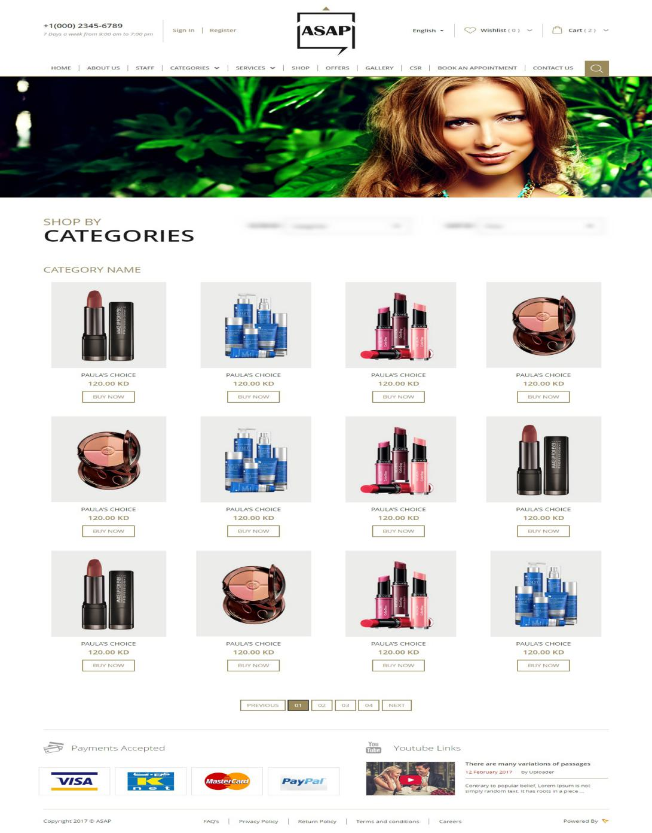

**Category View**

In the category details page the product can be filtered by category name and sort by price. The product name, default image and its price will be in the product list. On mouse over there will appear quick view button and it redirects to the product details page. Add to Cart button will quickly add a product to the cart. There will be pagination activate if the product list exceeds the view limit. This page has no left and right side bar and it includes the common header, footer.

All the products are added to each category by the admin from the admin panel.

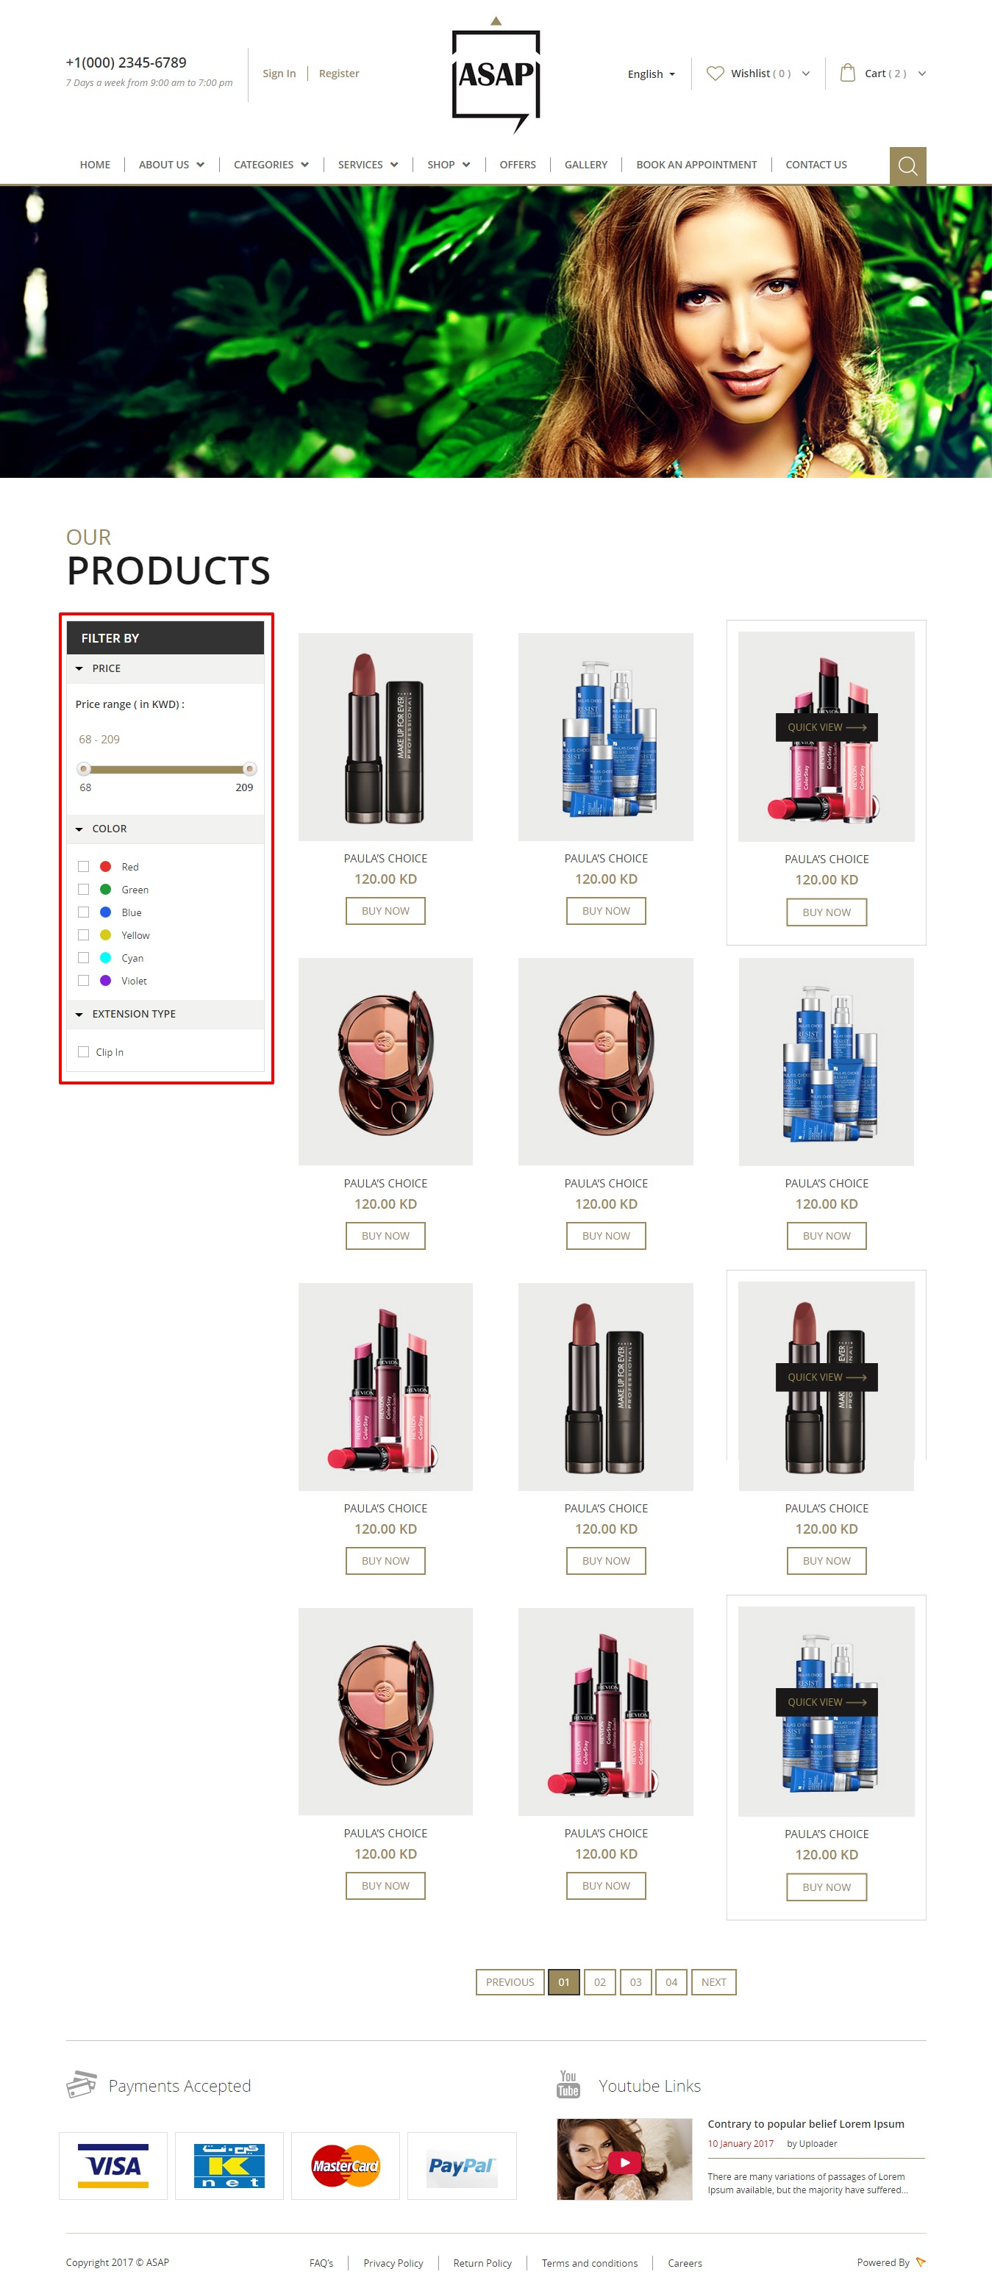

Product listing filter can be done by price, color and extension type.

**Product Detail View** 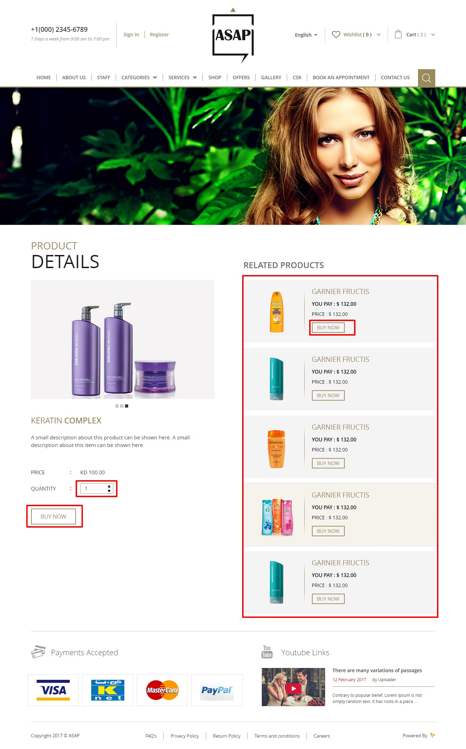

This page displays the selected product details name,images,price,description etc.

The content has two blocks, one is product details and other is related product list.

Product image, product name(will be bold) and its description are mention in this page. If there exist more than one product image it will be auto scroll. Product price and quantity are given below the description. User can choose more than one quantity for purchase order. There will be ‘Add to Cart’ button for add a product to his cart.

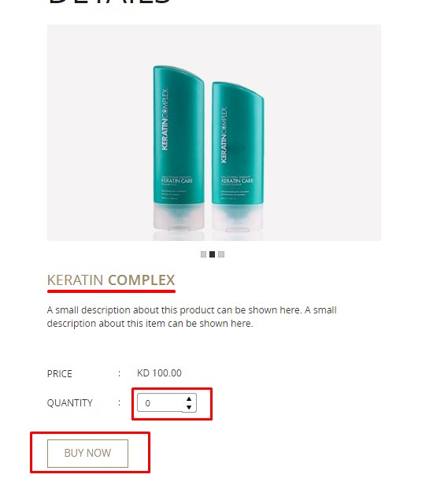

The Related products list contains the product name, image, price and Buy button. All the related products hyper linked to the product details page. Buy now button will add the product to the cart.

The related products mange from the admin panel. Admin can set a list of products as related items to a particular product.

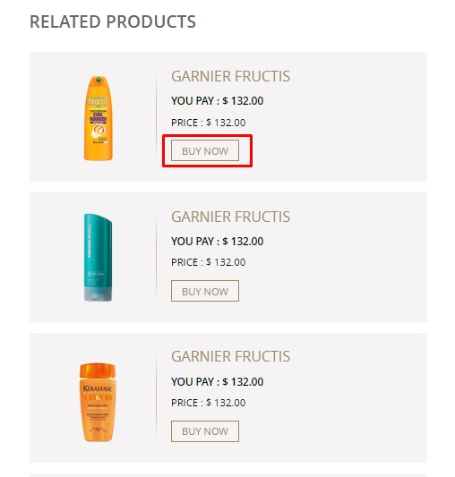

**Cart Page**

ere all the product purchased by the user will be listed with the details like Product name, Product small thumb, Unit price, Quantity, Total, Grand Total. Here you can remove a product from the cart. On clicking PROCEED TO CHECKOUT,if the user has logged in then it takes to shipping and payment pages otherwise ask to login to proceed check out. If one user select any product from the normal product listing page as well as from ASAPER profile page. So the those products are differentiate in the cart with two type of listing. If user select the product from ASAPER page it will listed with ASAPER profile image which is marked as “**1** “ in the given below screen shot. And normal product listing is marked as “**2**”

In the screen shot.

Cart page screen shot is given below.

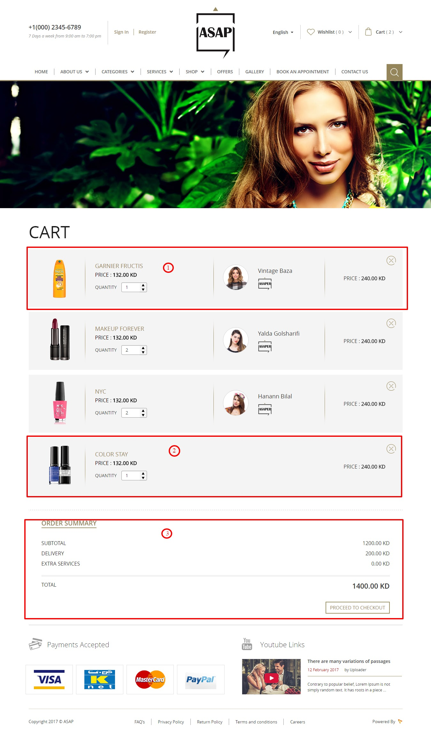

**Set Delivery Address Page**

The user has to set billing and delivery address before the payment process. In this page user can set both billing and shipping information. There will be an option to add more address and can set default as one. The order summery such as subtotal,shipping fee,extra charge and grand total will be on the right side of this page. After address completion user can press on the ‘Continue’ button and it will goes to the order review page.

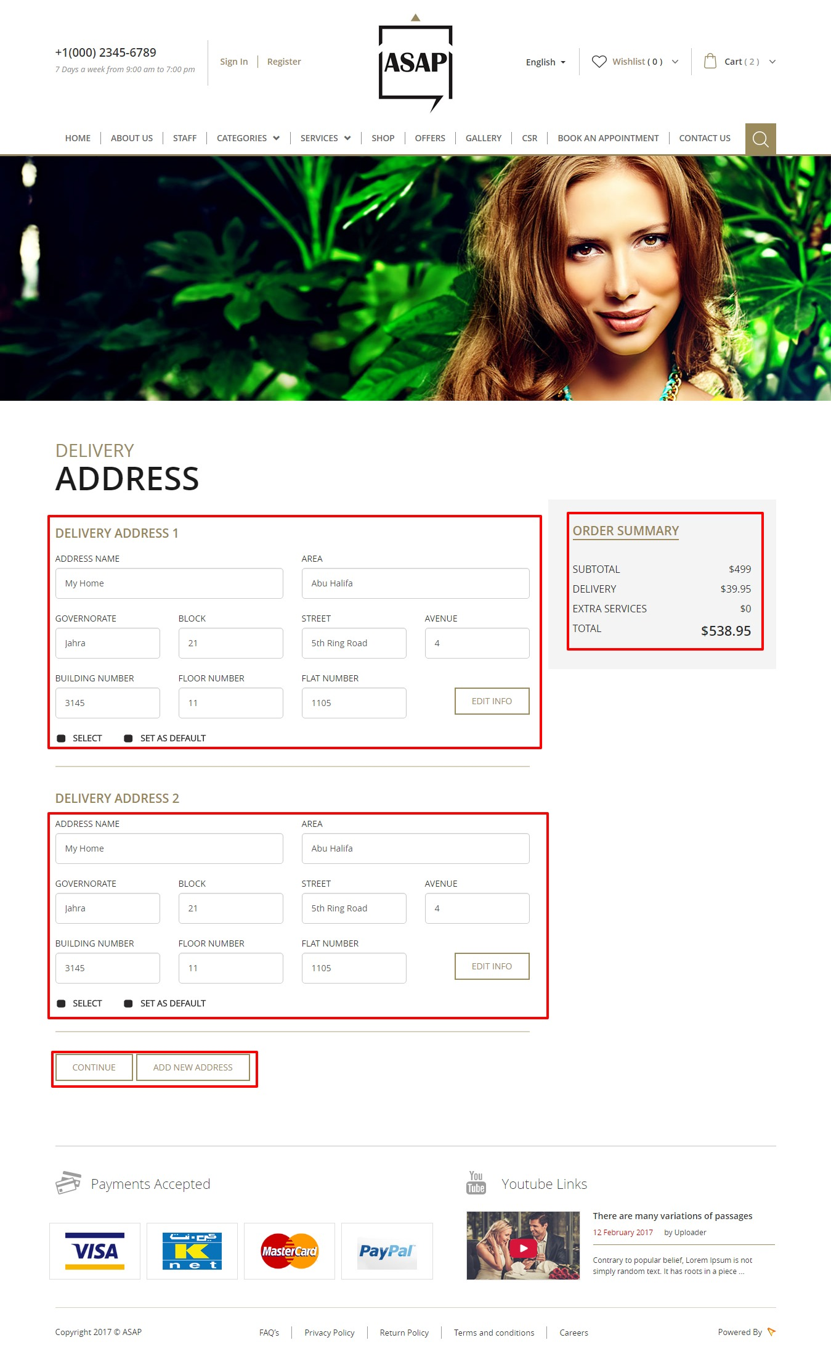

**Order Review Page**

This page shows the review of the cart items, delivery address and amount details. If the user wish to change his order data then just go back and update the details. Next the user ready pay the amount. The ‘Continue’ button will goes to the payment method page.

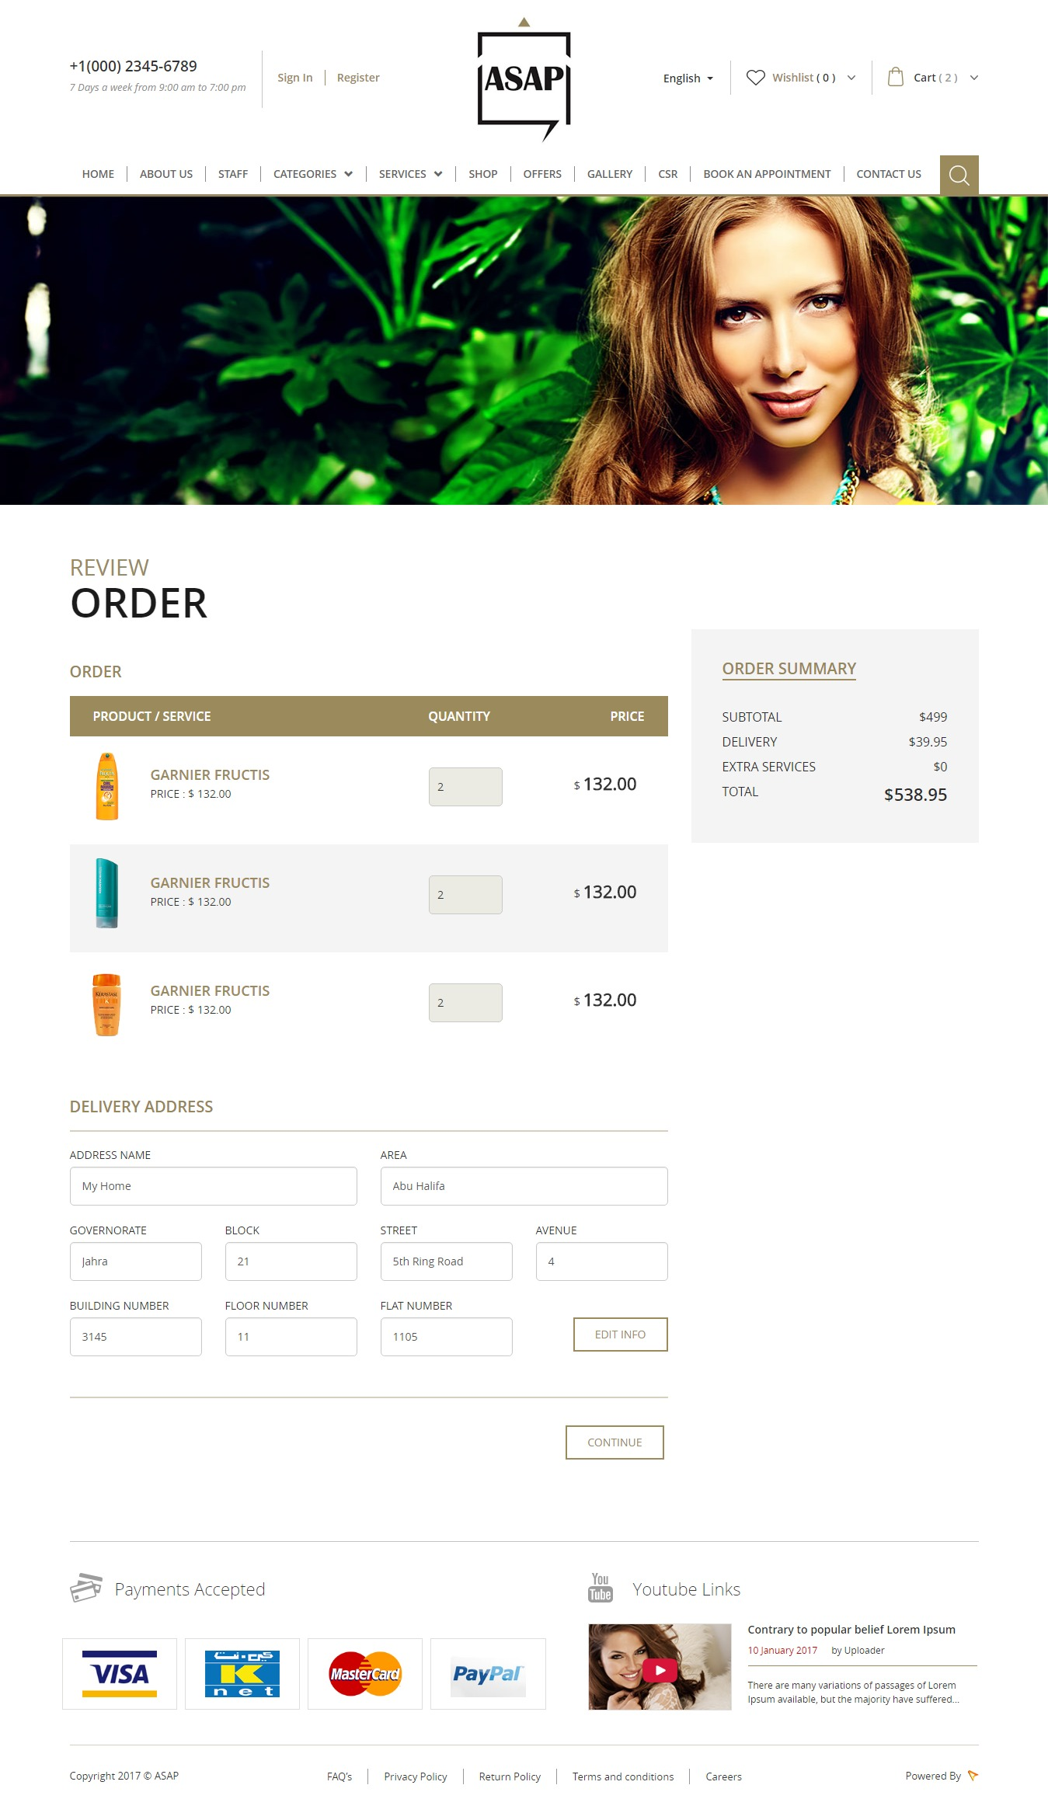

**Payment Page**

In this page user can choose payment methods from the options Visa, Knet, Master Card and Paypal. The order summery and the amount to be payable will mention there. To continue the payment click on ‘Complete Payment’ button the page will redirects to the payment gateway page.

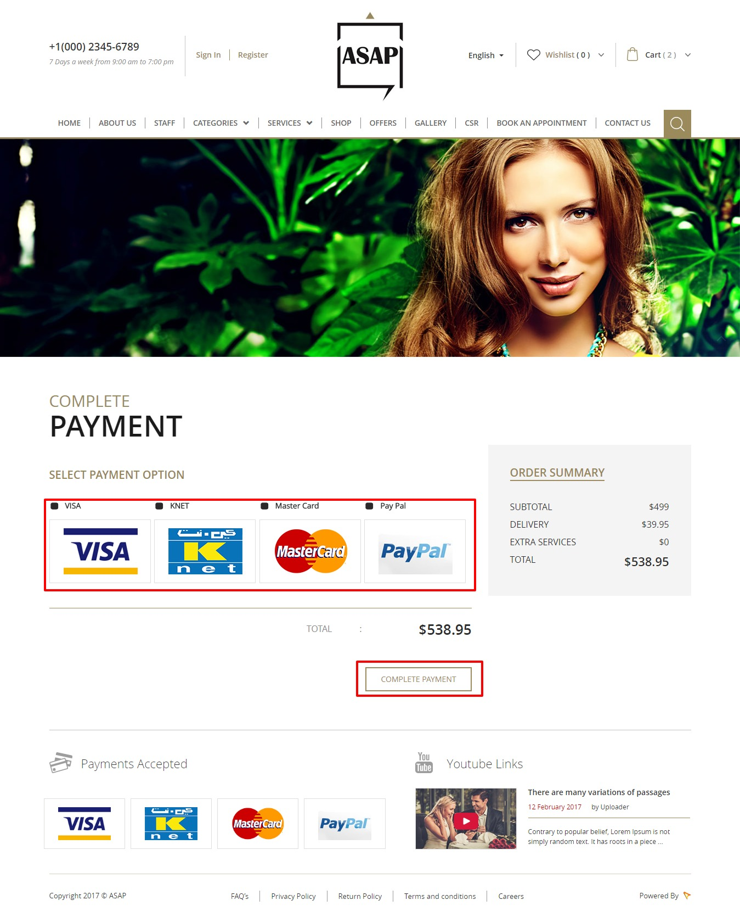

**Services Page**

This page listing all the active service categories Hair,Face,Nail etc. On click of the category will goes to its detail page. Category details page will listing all the services under the category.

The screen shot is given below.

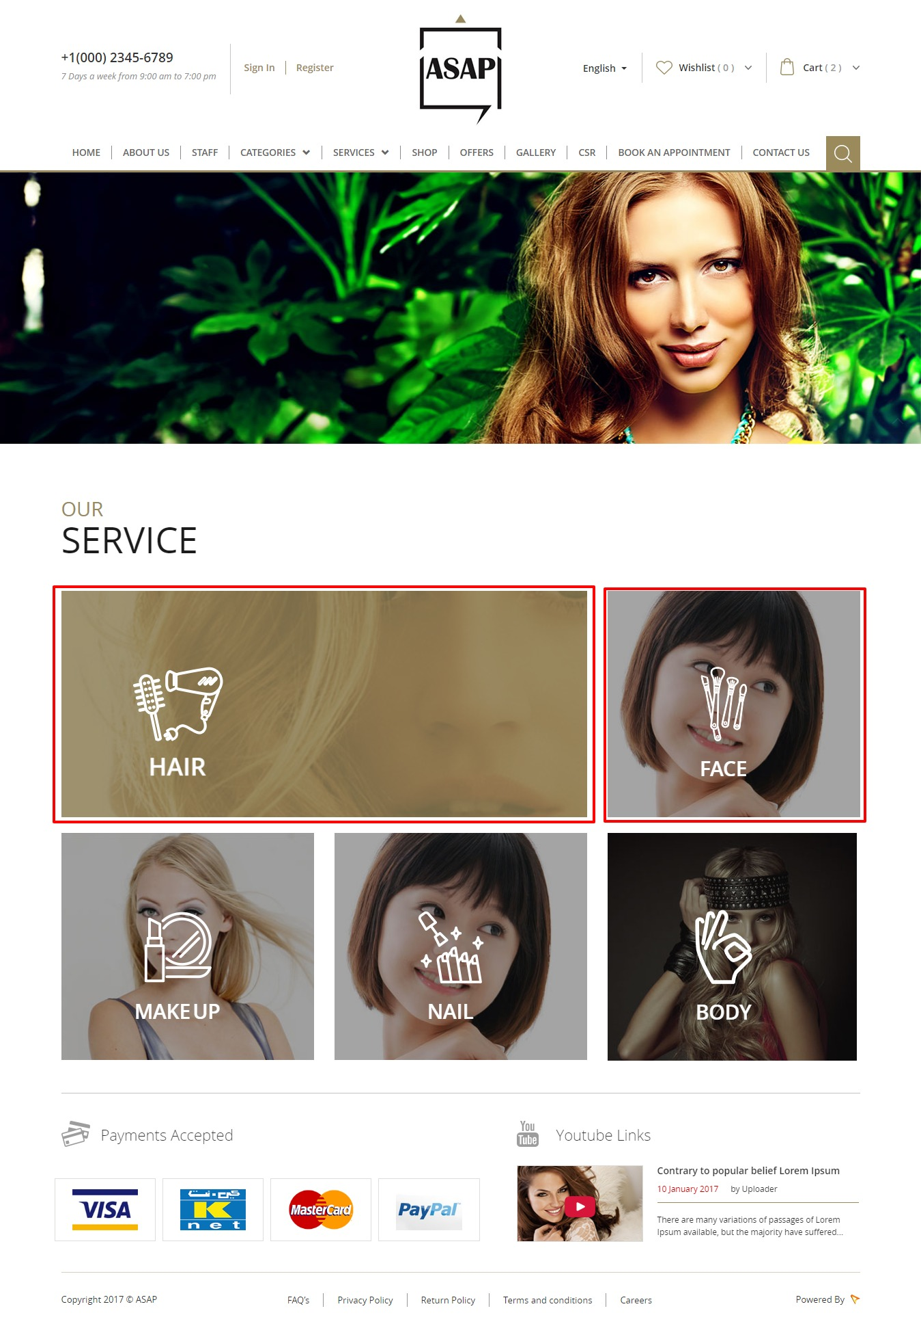

If a user select the service there will be listing service providing staff profiles. From the staff profile user can choose an appointment.

**Book an Appointment**

In this page contains the selected service and staff with his available dates as a calendar view. User can see the Booking Calendar there will the available time slots of the service or staff. There will be an option to see the staff or service information list in calendar.

User can select any staff member. This booking system offers a comprehensive reservation system where you can add your staff members with their profiles and available times so that customers can book your service with a person of their choice. User can select from this system which staff member is available for which bookable product or service.

The this booking form, customer choose a service from the service listing drop down box then the second staff listing drop box will auto load with staff name who are providing that service. From the auto loaded staff list customer can choose a staff name. Next there will a date picker to choose a date for the service. When select a date, then the available time slots of the staff will auto load and also the booked time and date in the calendar. Once the user select a time slot and submit the ‘Book Now’ button which will add a corresponding amount of money to cart when that staff is chosen. User can view the cart items that contains services then proceed to checkout and payment same as the steps mention in the product checkout process. The user must be login before proceed to checkout.

After review the service summery choose payment methods from the options Visa, Knet, Master Card and Paypal. The order summery and the amount to be payable will mention there. To continue the payment click on ‘Complete Payment’ button the page will redirects to the payment gateway page.

Page screen shot is given below.

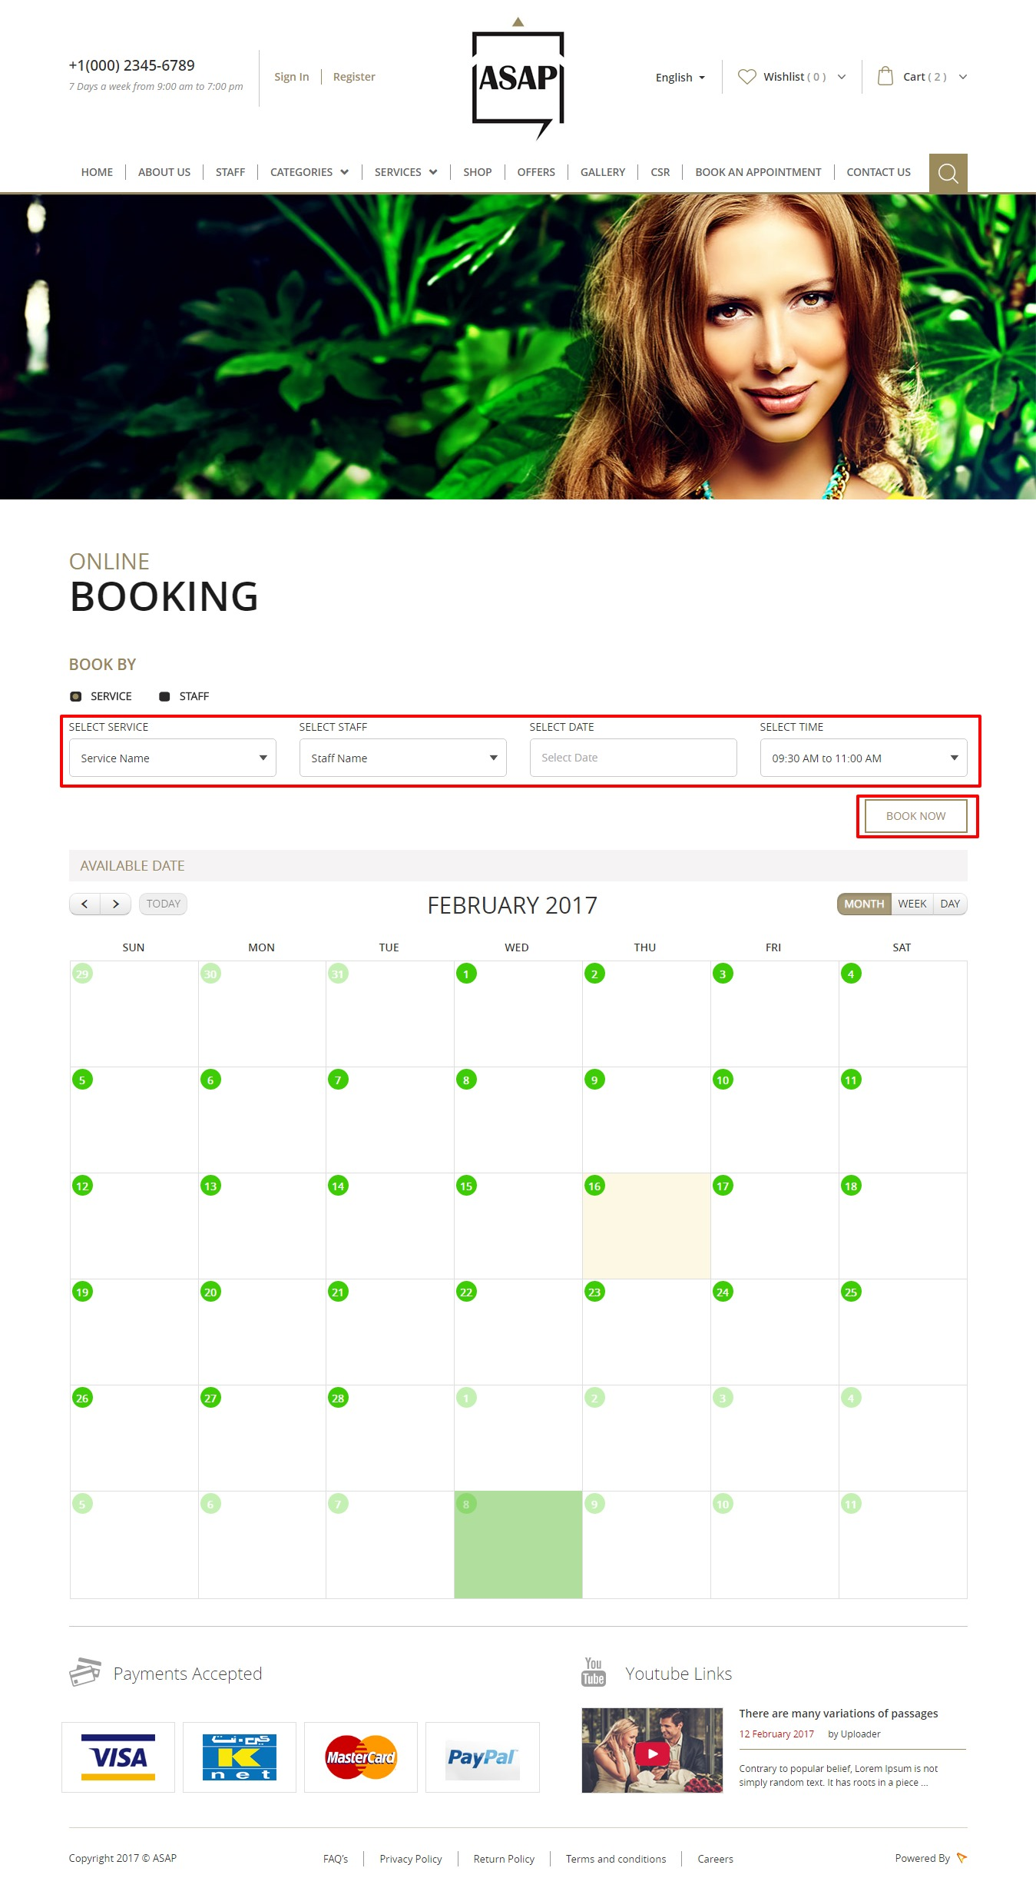

**Wishlist Page**

On clicking on wish list button it takes to wish list page. Listing users’s bookmarked items for future purchase. Item name with thumbnail,quantity and price informations are in the list. There you can add the item to cart or you can remove it from wish list.

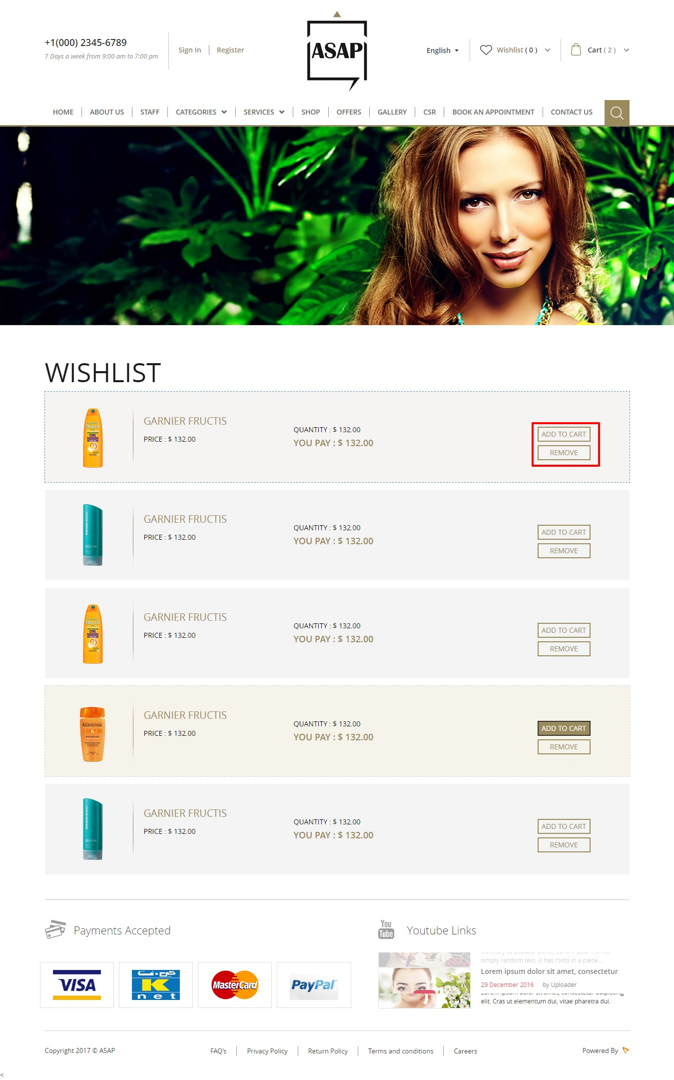

**Contact Us Page**

This page contains ASAP company contact address and Feedback form. The feedback form fields are Name,Email,Mobile no and Message. The form submit details will forward to site admin. There will be the embedded Google location map on the bottom of the page. 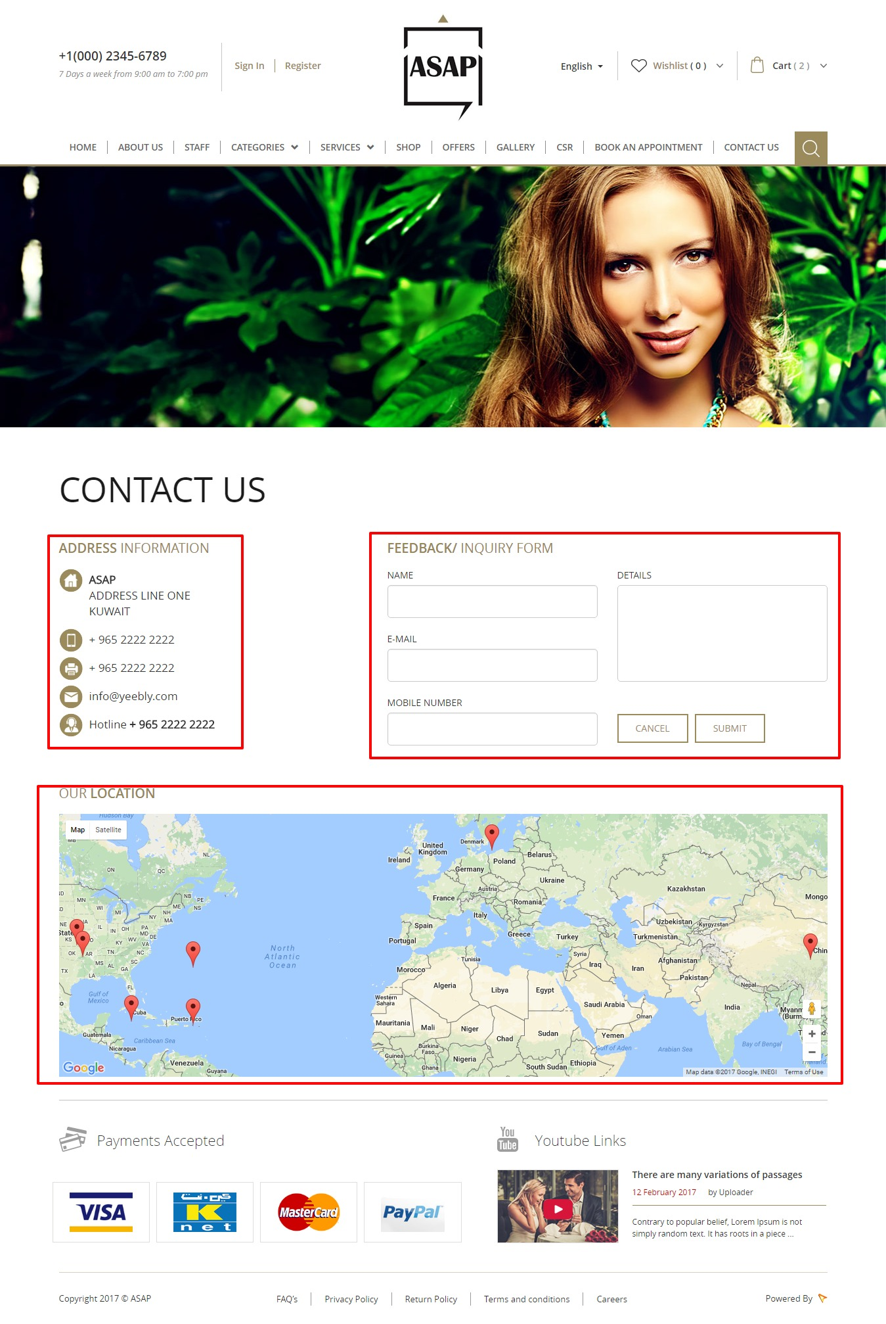

**User Registration**

This page is used to create new account with **ASAP**. The required user registration details are: First name,Last name,Email,Password,Mobile no and accept the terms and condition. After successful submission user need to activate his account from his email.

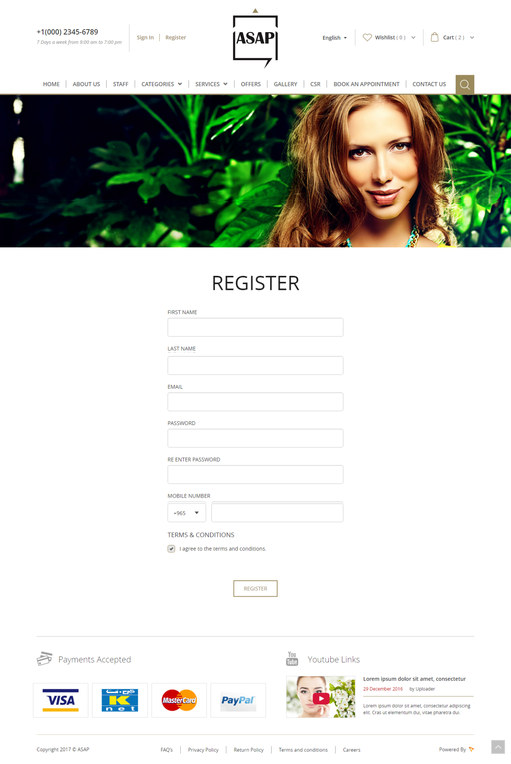

**Sign In Page**

User who registered with **ASAP** use this page to login. This page will load as popup. User can use either username or email and password for the login. After successful login it will take the user to his account. Where he can manage his details.

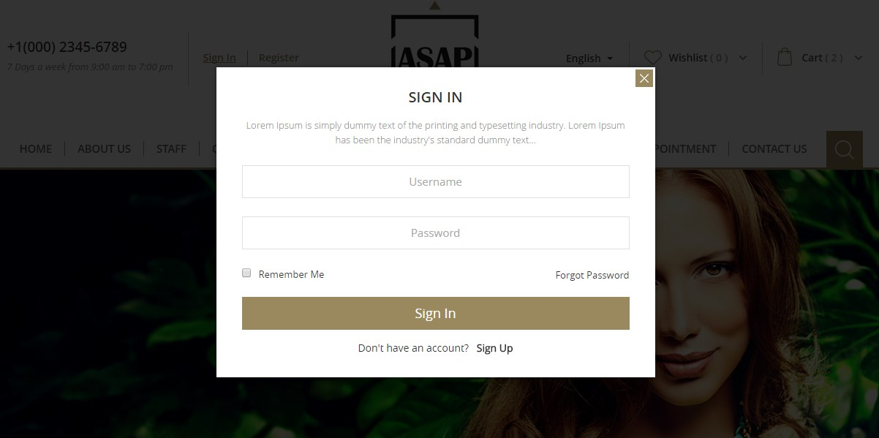

**Offers Page**

This page containing the latest offers for the users of the website. Offers are listing by the item name, thumbnail and its special price. All the offers are created by the admin and it will have limited period of time. Offer can sort by the item price. User can view the details of the offer by click on ‘Quick View’ button.

**Gallery Page**

In this page contains photo gallery and events are posted by the admin. All the gallery image with a title will appear on the mouse over. On click event of the image will open in a popup window. The back end admin can add the image with a title.

Events are listed on the right side of the page. All the events with its image,title and the date of that event. On click of the event will redirected to detailed page of that event. All the events are posted by admin user. The screen shot is given below.

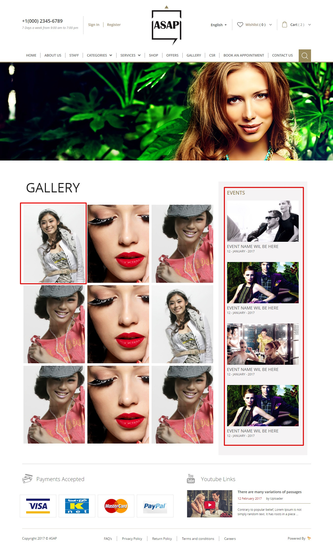

**CSR Page**

It contains the Corporate social responsibility contents added by the administrator. The content with bold title and a thumbnail. On click of the content will goes to the detailed page of that content.

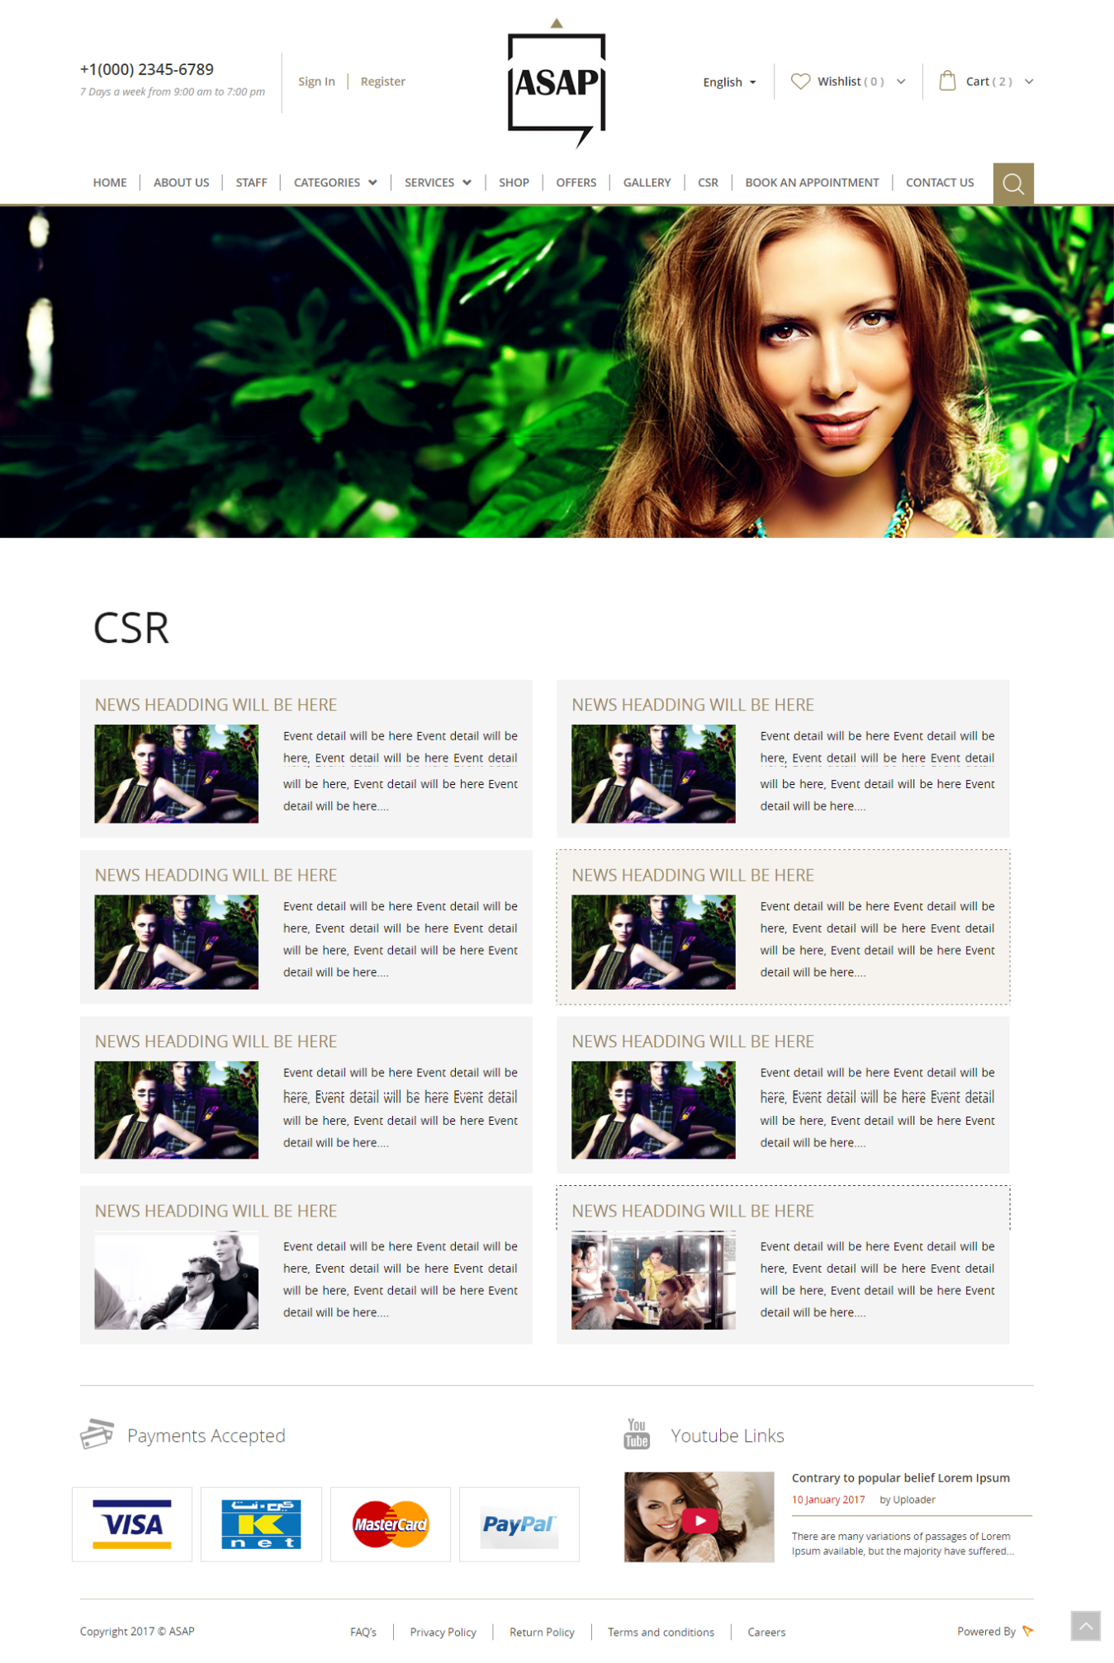

**Shop Page**

This page will listing all the products from the shop. There will be an option for product filter by category and sort by product price. On product mouse over, ‘Quick View’ button will be detailed view of that product and ‘Buy’ button will add that product in to cart.



**Administration Panel**

Administration side of the ASAP where you can manage Category, Products, Services, Contents, Orders, Offers, Customers, Reports, Payments, and much more.

### Admin Login

There will a unique username and password for the admin login.

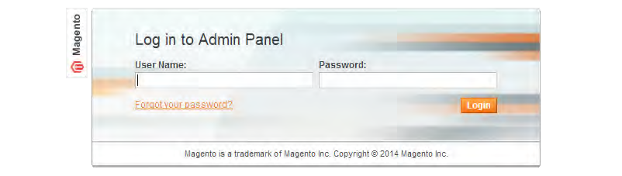

### Entering the administration through the Dashboard

After successful login, the user will re-direct to the Dashboard of the system. The dashboard is the first thing you will see when entering **ASAP**’s admin. The main function of the dashboard is to give the shop owner an overview of how the shop is performing.

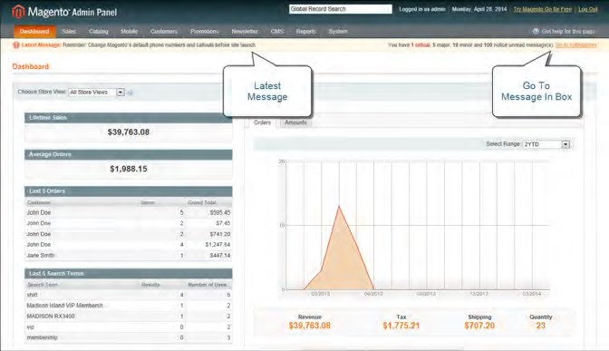

### Creating Product Category

Before you add products to your catalog, you must first establish the basic category structure of your catalog. Every product in your catalog must be assigned to at least one category. Admin can create new category in both English and Arabic languages. The created categories will listing with basic details. There will be an option to edit, delete and detailed view of categories. Similarly the admin can manage subcategory with additional field parent category.

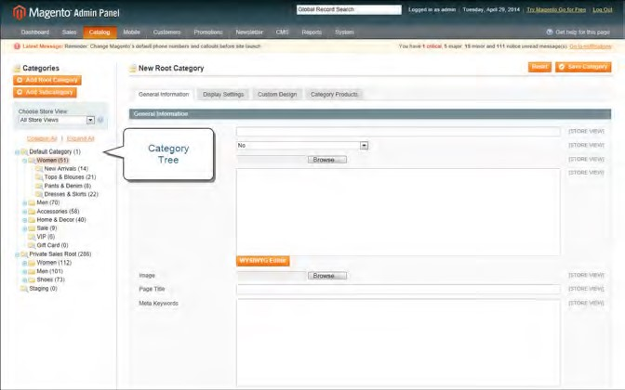

*CategoryTree*

Creating Products

All the products to this website can be managed though this section (Add/Edit/Delete). The product can add to this website like this way. Here the user can add details such as name, descriptions, price, specific features and images, etc. There are varies forms to create a product such as product basic information, price and stock details.

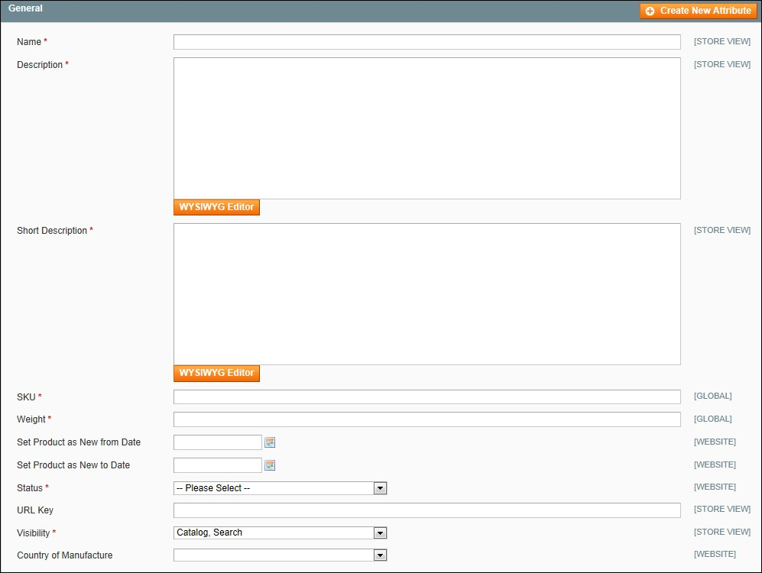

Product basic details.

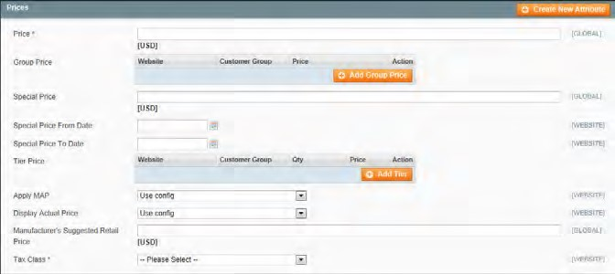

Product price details.

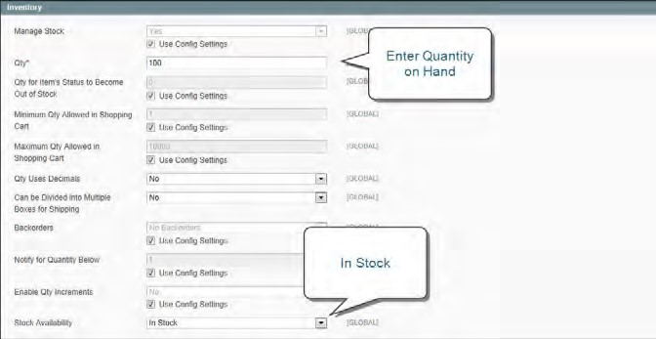

Product stock details.

Product Orders

Display list of customer orders with a link to detailed view. All orders have an order status and can see the status of an order by clicking the control at the top of the Status column.

When the order is placed, a sales order is created as a temporary record of the transaction. In the Orders list, sales orders are shown with a status of "Pending," and can be canceled at any time until the payment is processed. After payment confirmed, the order can be invoiced and shipped.

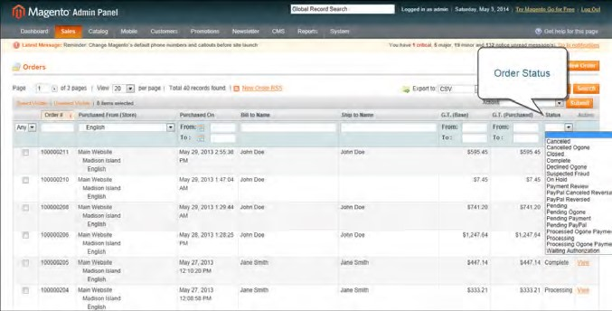

### Creating Service Category

Before you add services to your catalog, you must first establish the basic category structure of your catalog. Create a parent category as Service. Every services subcategories must be assigned to the parent service category. Admin can create new category in both English and Arabic languages. The created categories will listing with basic details. There will be an option to edit, delete and detailed view of categories.

Creating Staff

Admin can create staff profiles with their basic details and after that create a working schedule for the staff, including working weekdays, start and end time, and product ID. Moreover, staff can be assigned to a certain staff type, which will add a corresponding amount of money to cart when that staff is chosen.

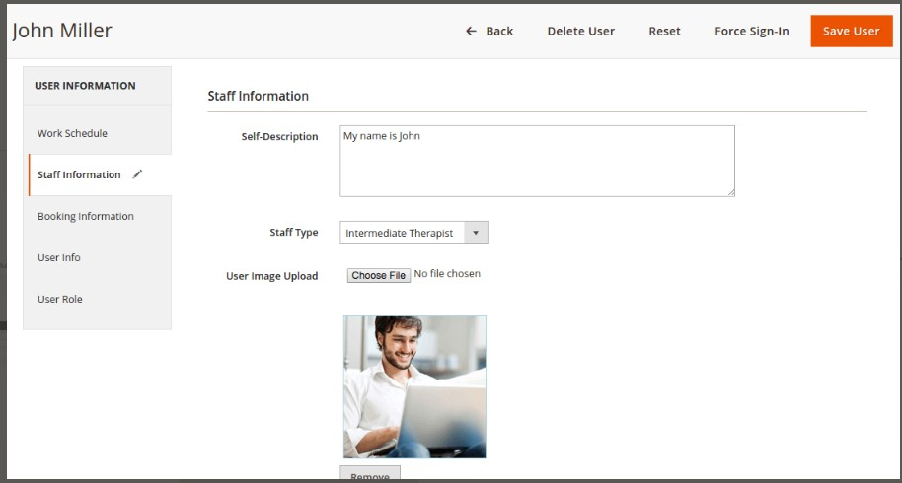

Staff informations details.

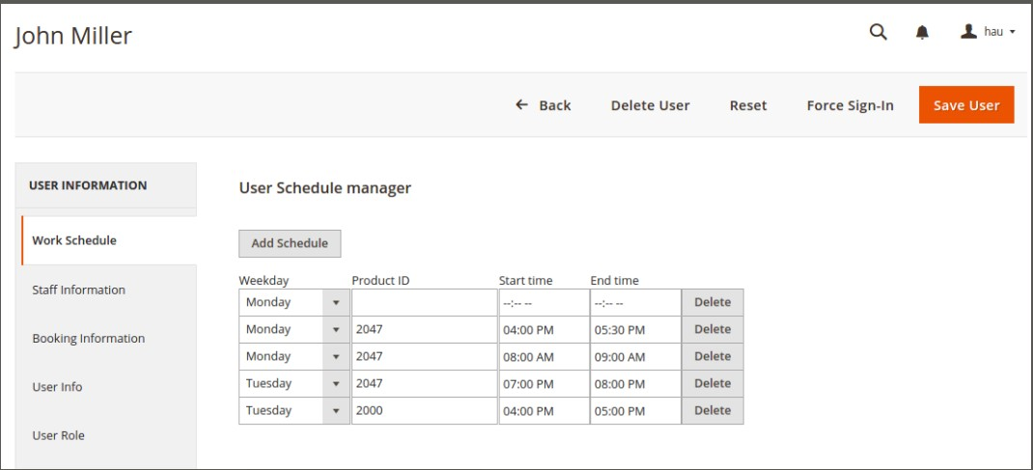

Staff work schedule details.

Creating Service Products

After the category and staff creation admin can add service products. All the products can be managed though this section (Add/Edit/Delete). Service products add form can be choose from the Add Products menu and choose the Appointment Booking menu.

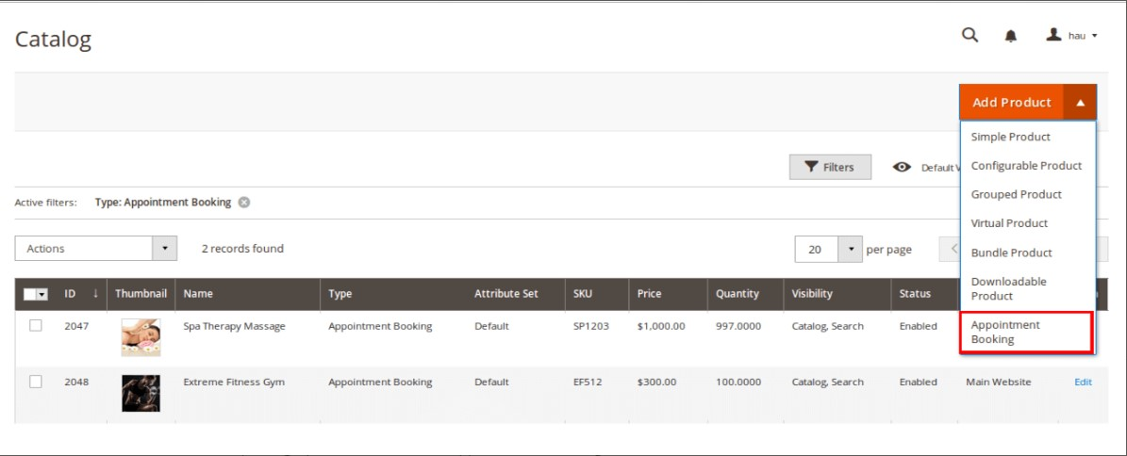

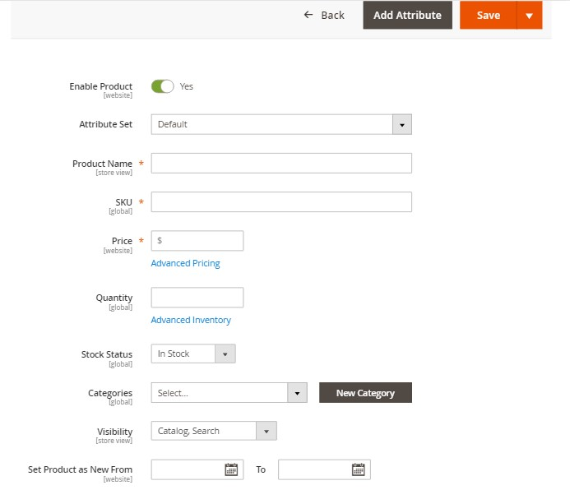

Service product add form.

After the product add, service time schedule should also be add. There will be Product Schedule Manager for adding time schedules to each service product. Admin can add each day with available time slots.

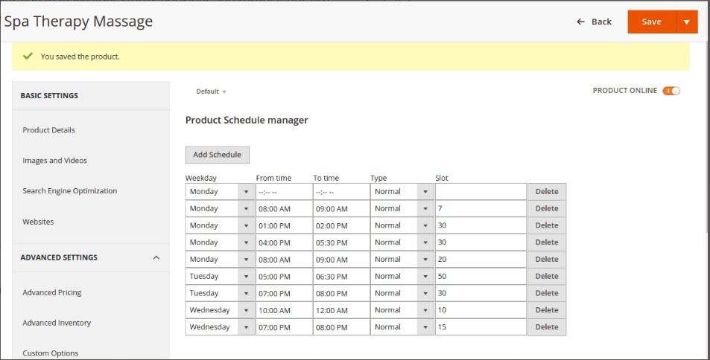

Product schedule manager.

Appointment Booking Orders

The customer appointment order information are in this section. The administrator can view all of the booking orders made on the site, manually edit the details of existing orders and can view the details such as appointment,customer and payment information.

The following details are displayed for each order on the list: Order ID,Product name,Booked date,Start date,end date,Staff name,Customer name,booking status.

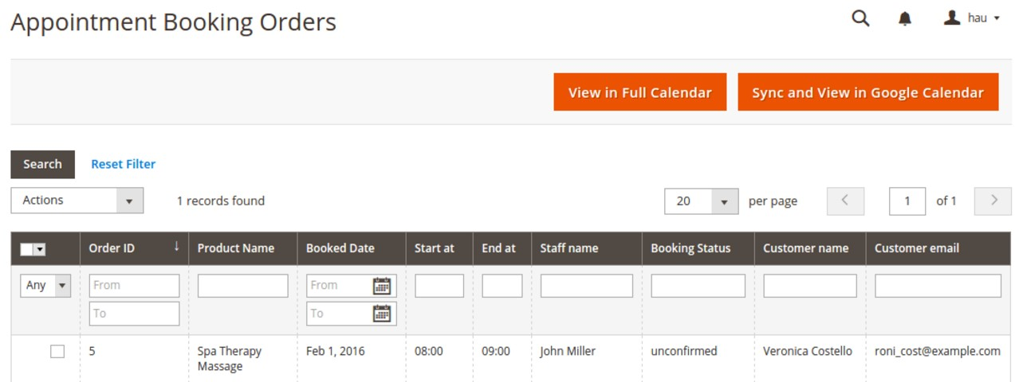

The orders can be view in a calender view.

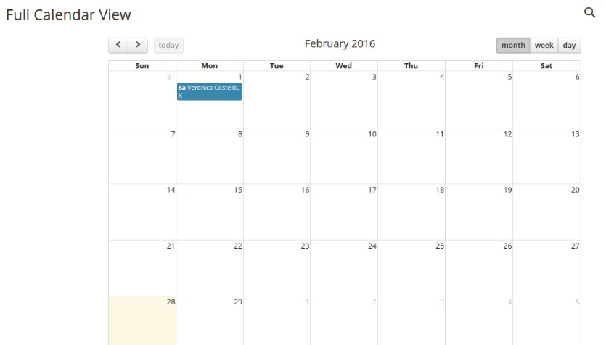

Customers

When a customer creates an account or completes the checkout process,ASAP will store their information automatically in the administration. A complete list of customers will be displayed on this page, along with the following information:

* **Customer Name**
* **E-mail**: Saves the email address for confirmation emails, notifications, newsletters, etc.
* **Status**: Denies or approves customer account login.
* **Approval**: Approves the customer account after creation.
* **IP**: An address that reveals the location of the customer.
* **Date Added**: The date the customer account was created.

Gallery

Gallery allows the admin to add image galleries to ASAP store which can be viewed by users in the front-end with lightbox effect. The Photo Gallery is fully manageable from the back-end and allows admin to easily add/remove/edit galleries and images. To create a new gallery, click on the Add button: You can input the name, photo, description, status, store view, etc… and save it.

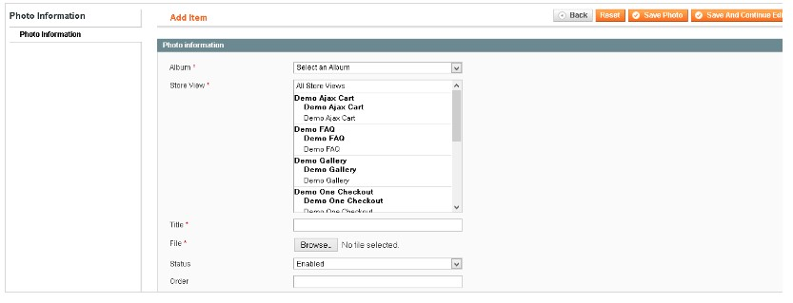

Offers

To offer a Special Price, enter a discounted price and complete the date range fields to establish when the promotion goes into effect. On both the catalog list and product pages, the regular price is crossed out, and the Special Price appears in bold red. To set an offer to a product, in the Product Information panel on the left, select price then enter the amount of the special price. Complete the Special Price From Date and Special Price To Date to define the period of time that the special price is in effect. You can pick the dates from the Calendar to the right of each field.

Reports

Admin panel provides a variety of reports that you can access at any time. To see the reports that you can generate in admin panel, from the Reports menu, select a type of report and then select a specific report of that type. Some report pages have filter controls that enable you to narrow the scope of the report. When you are finished making filter selections, click Show Report (or Refresh, in some reports) to generate the report.

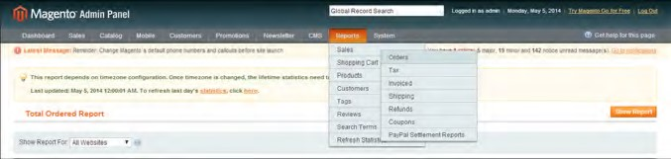

Reports menu.

**Order Report:**

The Orders report includes real-time data, and can include orders of any status during a specific period of time.

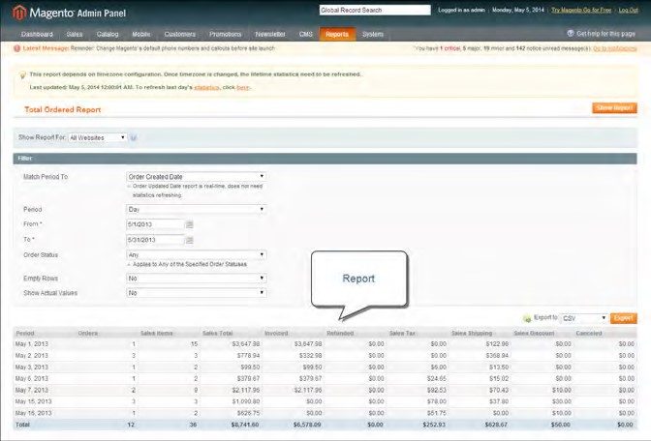

The Orders report displays the following information:

Orders,Sales Item,Sale Total,Invoiced,Sales Tax,Sales Shipping,Sales Discount,Cancelled etc.

After showing the reports list admin can export the result as CSV or Excel format.

User Characteristics

There are three types of users that interact with website as per the user requirement

* User1 – Super Admin (ASAP Super Administrator)

The Super Admin is managing the overall system. The super admin has the rights to create, update and delete an admin, a customer and have all access. He can enter all the information into database via admin panel.

* User2 – Admin (Shop Admin)

The admin has the rights to create a staffs profiles and assign them the services they can provide and create the availability calendars for each staff..

* User 3 – Website User (Customer)

The website user (Customer) uses the website for purchasing the products and services.

Specific Requirement

* User Registration

Considering that a customer has to purchase a product from the website, the user can register his/her details through login form. The user must provide email id, password and other details.

* Bilingual

The website is in two languages, English and Arabic

* Retrieve Password

If a user forgot his/her registered password, he/she can retrieve his password. New password will be e-mailed to his registered email id.

* Search

Search will help the user to find his requirement easily.

* ASAPER

This is a type of user, who have their own products for shopping. The product assigning other process will be handled by the website administrator itself. If any user purchased a product from the ASAPER profile that ASPER will get the commission rate on each purchase. This commission rate finally credited to the ASAPER bank account through website administrator. Admin can generate report based on ASAPER.

More Features

* Any buyer can become ASAPER and can sell their products on the site.
* Separate ASPAER Profile with Company Banner and Company Logo.
* Admin can assign or unassign product to any particular ASAPER.
* Using ASAPER dashboard ASAPER can track his income, latest order, comment and reviews, recent orders and recent comments with total sales matrix.
* Admin can deny/approve/disapprove ASAPER.
* Admin can view, approve, disapprove, update, deny and delete ASAPER requested product.
* Buyer can view all the details about the product is given by the ASAPER.
* Separate ASAPER’s product collection page.
* Different ASAPER commission for every ASAPER.
* Product Preview for product approval at admin.
* Admin can manage the ASAPER profile page setting.
* Admin can manage the inventory setting.
* The ASAPER will be notified by mail when product inventory reaches to the specified minimum level set by the admin.
* ASAPER can change their profile page background color.
* Allow ASPER to add Carrier and Tracking numbers for orders.
* The ASAPER can manage the order from the front-end when approved by admin.

Client Responsibilities

Client will be responsible for providing the below mentioned resources for the website

Magento Extension

The client need to be purchased the ‘**Appointment Bookin**g’ Magento Extension for the service booking system.

And also need to be purchased “**Magento Marketplace Multi Vendor Module**” Magento extension for the ASAPER module.

Content

The client needs to provide the content for each and every page in the website. This includes text, images, etc. for all the pages. If it is not provided by the client for any page, the specific page will be put with “Content will be available soon” text.

These contents needs to be provided for both English and Arabic versions of the website by the client.

SMTP

The client should provide the SMTP details for sending the emails from the website.

E-mails

The client should provide the admin emails for each and every form in the ASAP website that includes contact us form.

Social Media Links

The client is responsible for providing the social media account links, YouTube channel links of ASAP.

Webmail

The client is responsible for providing the webmail link of ASAP.